Full SoC Subsystem Integration 2
1. Title 2
2. Objective 2
3. Theory (Multi-Level) 2
3.1 Beginner — Simple Intuition 2
3.2 Intermediate — Engineering View 3
3.3 Advanced — Signal/Architecture Level 3
4. Architecture / Concept 4
Complete SoC Block Diagram 4
Memory Map (Definitive Reference) 5
5. Implementation 5
Files Used in This Module 5
Makefile Targets 5
6. Lab / Hands-on Section 6
Step 1: Run Full SoC Simulation 6
Expected Full Simulation Log 6
Step 2: Run Structured Debug SoC 7
Step 3: Open Waveform 7
Step 4: Run Synthesis 7
7. Waveform / Verification Insight 8
GTKWave Signal Groups for Full SoC Analysis 8
Key Timing Observations 8
8. Common Issues & Debug Tips 9
Synthesis Readiness Checklist 10
9. Summary 10

Table of Contents

Full SoC Subsystem Integration
Course: PicoRV32 SoC with AXI-Lite & UART Integration
Lab Commands: make soc → make debug_soc → make wave

1. Title
Full SoC Subsystem Integration — End-to-End System Verification of PicoRV32 + AXI-Lite + UART

2. Objective
By the end of this module, learners will be able to:
- Describe the complete PicoRV32 SoC hierarchy and all 9 RTL modules
- Explain how the address decoder routes CPU transactions to the correct slave
- Run make soc and make debug_soc to execute end-to-end system verification
- Interpret the complete simulation log showing greeting messages and PING echo
- Understand OpenLane synthesis flow and the ASIC-clean design requirements

3. Theory (Multi-Level)

3.1 Beginner — Simple Intuition
At this point, every piece you’ve built in Modules 1–7 comes together into one system:
Firmware (C code written in Sub-module 7)
↓
PicoRV32 CPU (Sub-module 1) executes instructions
↓
CPU-to-AXI bridge (Sub-module 5) translates native bus to AXI-Lite
↓
AXI Interconnect routes to:
├── ROM (stores the firmware instructions) [Sub-module 2 AXI slave]
├── SRAM (scratch memory) [Sub-module 2 AXI slave]
└── UART peripheral (Sub-module 3/6) [sends bytes to terminal]
The testbench (Sub-module 9) monitors UART output and verifies "PING" echo.
Think of it as assembling a complete computer from scratch and watching it run its first program.

3.2 Intermediate — Engineering View
Full RTL file list and roles:
File | Lines | Role
rtl/picorv32.v | ~3100 | PicoRV32 CPU (all RISC-V ISA logic)
rtl/top.v | 333 | SoC top: CPU + bridge + wiring
rtl/axi_lite_interconnect.v | 227 | 1-master, 3-slave AXI-Lite router
rtl/axi_decoder.v | 165 | One-hot address decoder (ROM/SRAM/UART)
rtl/rom.v | 212 | AXI-Lite ROM (firmware storage)
rtl/sram.v | 145 | AXI-Lite SRAM (data + stack)
rtl/uart_axi.v | 250 | UART peripheral with AXI-Lite slave
rtl/uart_tx.v | 124 | UART 8N1 transmitter FSM
rtl/uart_rx.v | 143 | UART 8N1 receiver FSM with 2-FF sync
ASIC-clean requirements (enforced throughout): - No initial blocks (other than in TB or sim-only ifdef paths) - No inline register initializers (no reg foo = 1'b0) - All state driven by synchronous posedge reset - No combinational loops - All outputs have defined values in all states (no inferred latches)

3.3 Advanced — Signal/Architecture Level
Complete address map (from rtl/axi_decoder.v):
casez (addr)
32'h0000_????: sel = 3'b001; // ROM (0x0000_0000 – 0x0000_FFFF)
32'h0001_????: sel = 3'b010; // SRAM (0x0001_0000 – 0x0001_FFFF)
32'h1000_000?: sel = 3'b100; // UART (0x1000_0000 – 0x1000_000F)
default: sel = 3'b001; // Default → ROM (safe)
endcase
AXI interconnect routing logic (for write address channel):
// One-hot fanout to all slaves simultaneously
assign s0_axi_awvalid = m_axi_awvalid & wr_sel[0]; // ROM
assign s1_axi_awvalid = m_axi_awvalid & wr_sel[1]; // SRAM
assign s2_axi_awvalid = m_axi_awvalid & wr_sel[2]; // UART
// Only the selected slave's awready propagates back to master
assign m_axi_awready = (wr_sel[0] & s0_axi_awready) |
(wr_sel[1] & s1_axi_awready) |
(wr_sel[2] & s2_axi_awready);
The transaction tracking registers (wr_sel_r, rd_sel_r, wr_active, rd_active) ensure that even if the address changes after a transaction starts, the response is correctly routed back to the master.
Reset sequence in rtl/top.v: - reset input is active-HIGH - Drives resetn = ~reset to PicoRV32 (which uses active-LOW reset) - All slaves see active-HIGH reset
PicoRV32 SoC port pinout (rtl/top.v):
module top (
input clk, // 50 MHz system clock
input reset, // Active-HIGH synchronous reset (drive for ≥ 2 cycles)
output uart_tx, // UART serial output (to terminal or testbench monitor)
input uart_rx // UART serial input (from testbench or host)
);

4. Architecture / Concept

Complete SoC Block Diagram
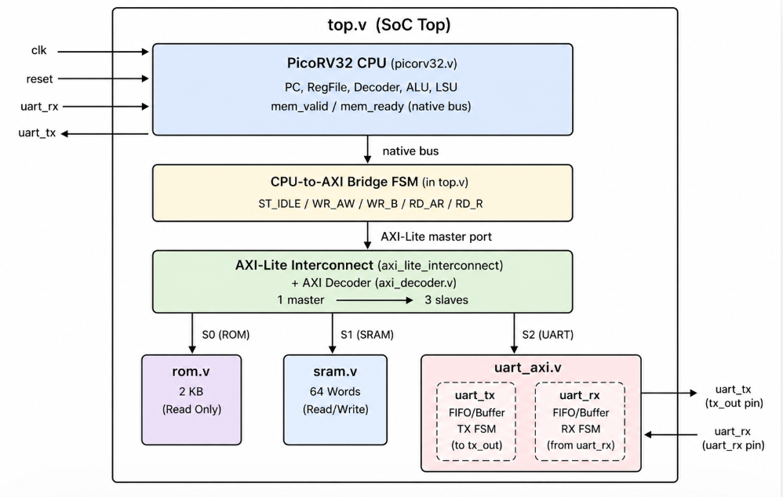

Memory Map (Definitive Reference)
Range | Slave | Size | Interface
0x0000_0000 – 0x0000_FFFF | ROM | 64KB (logical) / 2KB (depth) | AXI-Lite S0
0x0001_0000 – 0x0001_FFFF | SRAM | 64KB (logical) / 256B (depth) | AXI-Lite S1
0x1000_0000 – 0x1000_000F | UART | 16 bytes | AXI-Lite S2
Note: ROM depth is MEM_DEPTH=2048 words = 8KB but address window is 64KB (upper bits ignored). SRAM depth is 64 words = 256 bytes.

5. Implementation

Files Used in This Module
File | Role
rtl/top.v | SoC top-level (CPU + bridge + interconnect wiring)
rtl/axi_lite_interconnect.v | AXI-Lite routing fabric
rtl/axi_decoder.v | One-hot address decode
rtl/rom.v | AXI ROM (dual-path: sim uses $readmemh, synth uses case-ROM)
rtl/sram.v | AXI SRAM with byte-enable write
rtl/uart_axi.v | UART with AXI-Lite slave interface
rtl/uart_tx.v | TX FSM
rtl/uart_rx.v | RX FSM with 2-FF sync
rtl/picorv32.v | Full PicoRV32 core
tb/tb_top.v | Full system testbench with UART byte monitor + PING test
tb/tb_debug.v | Structured debug testbench with more verbose signal logging
rtl/rom.hex | Firmware binary in hex format (generated by make fw)

Makefile Targets
make soc # fw + verilate all RTL + tb_top.v → sim_soc → tb_top.vcd
make debug_soc # fw + verilate all RTL + tb_debug.v → sim_verilator → tb_top_debug.vcd
make synth # Yosys synthesis using openlane_design/src/ with -D SYNTHESIS

6. Lab / Hands-on Section

Step 1: Run Full SoC Simulation
cd /home/deep/nielit/projects/tested_projects/picorv32_soc
make soc
This command: 1. cd fw && make — builds rom.hex 2. verilator --binary --trace --timing — compiles ALL 9 RTL files + tb_top.v 3. Runs ./obj_soc/sim_soc +romhex=rtl/rom.hex → produces tb_top.vcd 4. Converts to FST: vcd2fst tb_top.vcd tb_top.fst 5. Opens GTKWave: gtkwave tb_top.fst &

Expected Full Simulation Log
--------------------------------------------------
UART SoC Simulation Started
--------------------------------------------------
[ROM] loaded from plusarg: rtl/rom.hex
[TB] UART Monitor Started
--------------------------------------------
[TB] RX byte: H
[TB] RX byte: e
[TB] RX byte: l
[TB] RX byte: l
[TB] RX byte: o
[TB] RX byte:
[TB] RX byte: D
[TB] RX byte: e
[TB] RX byte: e
[TB] RX byte: p
[TB] RX byte: a
[TB] RX byte: k
[TB] RX byte:
[TB] RX byte: f
[TB] RX byte: r
[TB] RX byte: o
[TB] RX byte: m
[TB] RX byte:
[TB] RX byte: N
[TB] RX byte: i
[TB] RX byte: e
[TB] RX byte: l
[TB] RX byte: i
[TB] RX byte: t
[TB] RX byte: !
Hello Deepak from Nielit!
[TB] Greeting message count = 1
...
[TB] Greeting message count = 10
============================================
10 GREETING MESSAGES RECEIVED
UART OUTPUT VERIFIED
============================================
--------------------------------------------
[TB] Greeting phase finished
--------------------------------------------
--------------------------------------------
[TB] FIFO flushed – sending command : PING
--------------------------------------------
[TB] RX byte: P
[TB] RX byte: I
[TB] RX byte: N
[TB] RX byte: G
============================================
TEST PASSED
Echo received : PING
============================================
- Verilator: $finish at ~23ms simulated time; walltime ~1.2s

Step 2: Run Structured Debug SoC
make debug_soc
This uses tb/tb_debug.v which provides more verbose signal-level logging during the simulation, producing tb_top_debug.fst.

Step 3: Open Waveform
make wave # Opens tb_top.fst in GTKWave
For the debug waveform:
gtkwave tb_top_debug.fst &

Step 4: Run Synthesis
make synth
This runs Yosys synthesis using: - Source files in openlane_design/src/ - -D SYNTHESIS flag (activates case-ROM in rom.v, bypasses $readmemh) - Outputs: top.json (netlist) and synth.v (synthesized Verilog)

7. Waveform / Verification Insight

GTKWave Signal Groups for Full SoC Analysis
Group 1: CPU Interface
clk
reset
u_dut.u_cpu.mem_valid
u_dut.u_cpu.mem_instr
u_dut.u_cpu.mem_ready
u_dut.u_cpu.mem_addr[31:0]
u_dut.u_cpu.mem_wstrb[3:0]
u_dut.u_cpu.mem_wdata[31:0]
u_dut.u_cpu.mem_rdata[31:0]
Group 2: AXI Bridge
u_dut.b_state[2:0] ← 0=IDLE, 1=WR_AW, 2=WR_B, 3=RD_AR, 4=RD_R
u_dut.m_axi_awaddr[31:0]
u_dut.m_axi_awvalid
u_dut.m_axi_awready
u_dut.m_axi_bvalid
u_dut.m_axi_arvalid
u_dut.m_axi_arready
u_dut.m_axi_rvalid
u_dut.m_axi_rready
u_dut.m_axi_rdata[31:0]
Group 3: Interconnect
u_dut.u_interconnect.wr_sel[2:0] ← one-hot: 001=ROM, 010=SRAM, 100=UART
u_dut.u_interconnect.rd_sel[2:0]
u_dut.u_interconnect.wr_active
u_dut.u_interconnect.rd_active
Group 4: UART
uart_tx_pin ← top-level serial output
u_dut.u_uart.buf_valid
u_dut.u_uart.rx_buf_valid
u_dut.u_uart.u_tx.state[1:0]
u_dut.u_uart.u_rx.state[1:0]

Key Timing Observations
Event | Approximate Time | What to See
Reset released | ~200 ns | b_state goes to IDLE; mem_addr = 0x0
First instruction fetch | ~220 ns | m_axi_araddr=0x0000_0000, rd_sel=001
First UART write (‘H’) | ~few µs | m_axi_awaddr=0x1000_0000, wr_sel=100
UART TX serial bit | ~first byte | uart_tx_pin drops to 0 (start bit)
All 10 greetings sent | ~23 ms sim | 260 bytes × 86.8 µs = 22.6 ms
PING echo completes | ~23.4 ms | TEST PASSED log

8. Common Issues & Debug Tips
Issue | Likely Cause | Fix
make soc fails: ROM not loaded | +romhex= path wrong | Check Makefile line 202: +romhex=$(RTL)/rom.hex
Simulation produces 0 greetings | Firmware not built | Run make fw first; verify rtl/rom.hex is non-empty
CPU stuck after reset | Bridge FSM bug | Add $display for b_state transitions
wr_sel shows 3’b000 | Address not decoded | Check axi_decoder.v — does address match any case?
UART TX always 1 (idle) | buf_valid never set | Trace aw_got and w_got in uart_axi.v
bvalid never seen | Wrong wr_sel causing wrong slave | Verify interconnect routes to UART for 0x10000000
Synthesis: “uart_tx has no driver” | Port name collision (known, fixed) | Already resolved: tx_out rename in uart_axi.v
OpenLane ABC error: combinational network | Timing retime command on mapped FFs | Non-fatal; documented in uart_tx_no_driver_analysis.md
Verilator simulation is slow | Large VCD from tb_mem_soc.vcd (142 MB) | Use FST format: vcd2fst then view .fst file

Synthesis Readiness Checklist
□ No inline reg initializers (= value) in any RTL
□ No initial blocks in RTL (only in testbenches)
□ All outputs have defined values in all states (no latches)
□ Simulation passes: 10 greetings + PING echo → TEST PASSED
□ synthesis path in rom.v tested: `make synth` runs without errors
□ No multi-driven nets (Verilator -Wall finds these)
□ Reset is synchronously sensed with correct polarity

9. Summary
Module | Component | Status
PicoRV32 CPU | rtl/picorv32.v | Parameterized RV32I; boots from 0x0000_0000
CPU-AXI Bridge | rtl/top.v (lines 91–224) | 5-state FSM; write + read paths
AXI Interconnect | rtl/axi_lite_interconnect.v | 1M → 3S; address-tracked routing
Address Decoder | rtl/axi_decoder.v | Combinational one-hot; casez match
ROM | rtl/rom.v | Dual-path: sim=$readmemh, synth=case-ROM
SRAM | rtl/sram.v | 64-word× 32-bit; byte-enable write
UART peripheral | rtl/uart_axi.v + uart_tx.v + uart_rx.v | AXI slave; 1-byte TX buffer; 2-FF RX sync
Firmware | fw/main.c + crt0.S + link.ld | 167 bytes; greets 10× then echoes
Testbench | tb/tb_top.v | UART monitor + PING test → TEST PASSED
Lab Result | Full system | 10 greetings verified + PING echoed → TEST PASSED
This is the culmination of the course. The full design is ASIC-clean, simulation-verified, and synthesis-ready. The same RTL flows directly into OpenLane2 for physical design.
Previous: Sub-module 7 — Firmware
Next: Sub-module 9 — Waveform Analysis

